Zid’Avwa Al Bari’i
244107020083 / TI – 2I / 26
All the code here is on GitHub
https://github.com/ZidAvwa/CollegeStudy/tree/main/3rdSemester/11.%20Jobsheet11

Jobsheet 11

Exercise 1

Codes
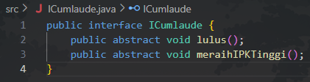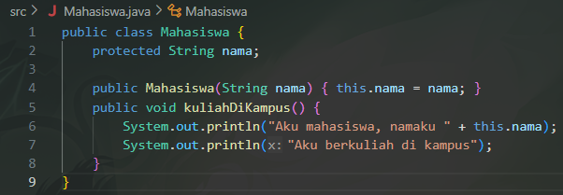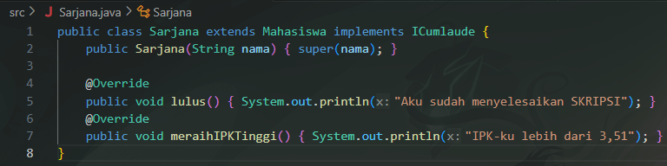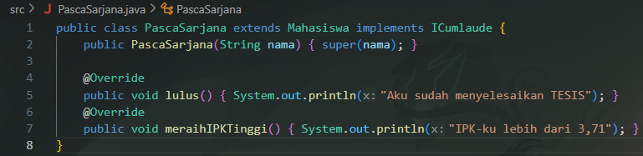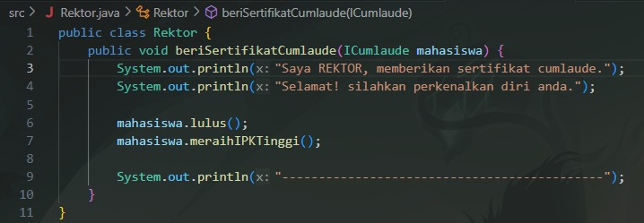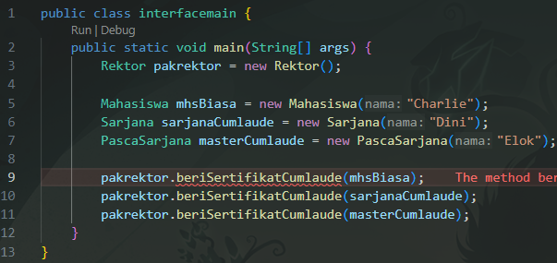
To fix the error just remove mhsBiasa
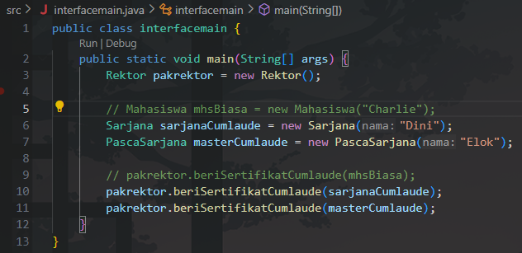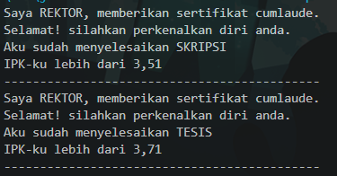

PRACTICE QUESTION 1
- In step 9, why is there a warning on the 3rd line?
The warning on import interfacelatihan.ICumlaude; appears because the ICumlaude interface was imported but never used directly in that specific file (the Program class). The IDE is just letting you know the import isn't necessary.
- 2. What happens if the 3rd line (import) is omitted?
If you remove the import, and any code in that file tries to explicitly use the ICumlaude type (for example, ICumlaude mhs;), the program will fail to compile. It won't know what ICumlaude is.
- Why did an error occur in step number 9?
The beriSertifikatCumlaude method requires a parameter that implements the ICumlaude interface. The mhsBiasa object is just a plain Mahasiswa. If you look at the Mahasiswa class definition, it does not implement ICumlaude.
- Can the kuliahDiKampus() method be called from a Sarjana object?
Yes. The Sarjana class extends the Mahasiswa class. Because of inheritance, Sarjana automatically gets all the public methods from Mahasiswa, including kuliahDiKampus().
- Can kuliahDiKampus() be called from the mahasiswa parameter inside the Rektor's beriSertifikatCumlaude method?
No. The parameter is declared as type ICumlaude. The compiler only allows you to call methods defined in the ICumlaude interface (lulus() and meraihIPKTinggi()), even if the object passed in also has other methods.
- Modify the beriSertifikatCumlaude method in the Rektor class for the new output.
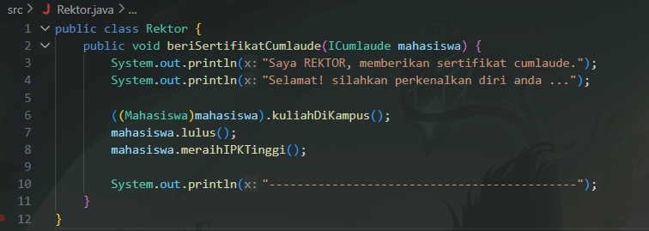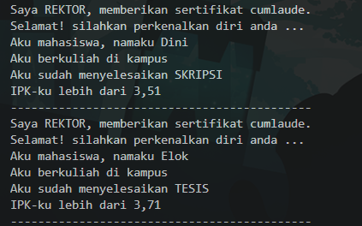

Exercise 2

Modified Code
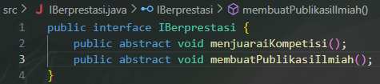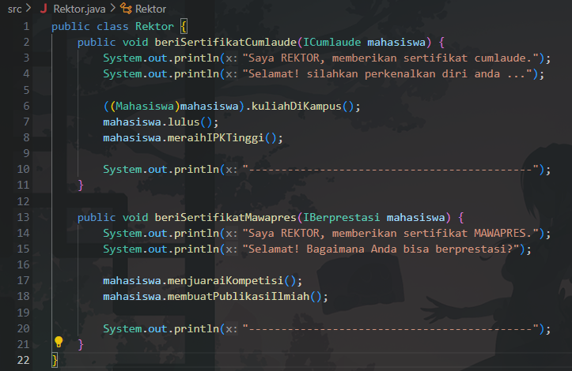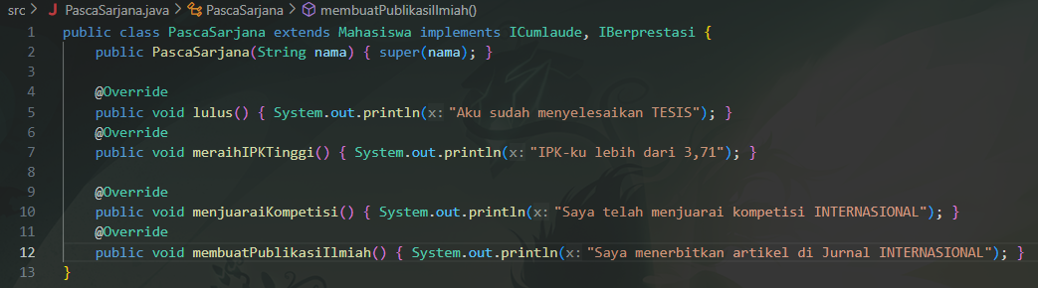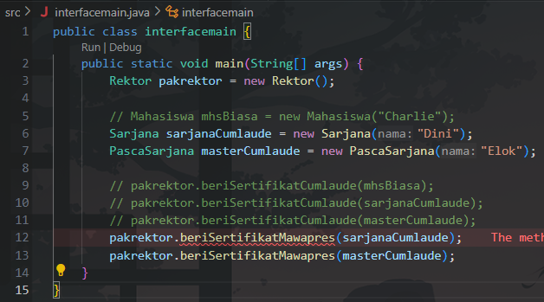
To fix the error just do the same for the Sarjana.java
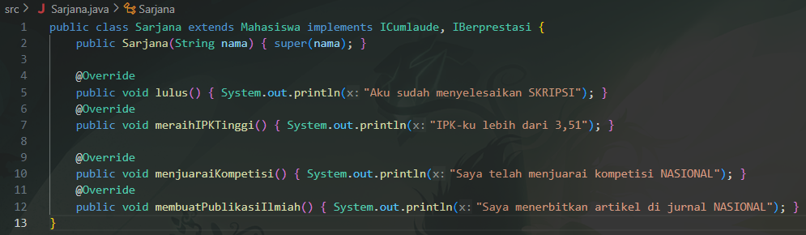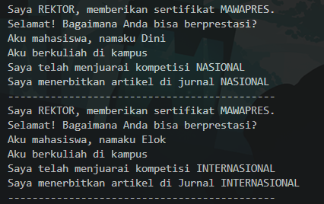

PRACTICE QUESTION 2
- From the script changes, what happened and explain the reason?
Any class that implements IBerprestasi is now forced to provide its own code for the menjuaraiKompetisi() and membuatPublikasiIlmiah() methods.
- Explain why the script code IBerprestasi prestasi = new IBerprestasi(); is wrong.
cannot create an instance (an object) directly from an interface. An interface is just an abstract template or a set of rules. You can only create objects from a concrete class (like Sarjana or PascaSarjana) that implements the interface.
- Match the output
To fix the error just do the same for the Sarjana.java

Assignment

Code
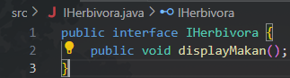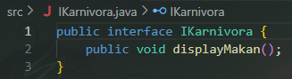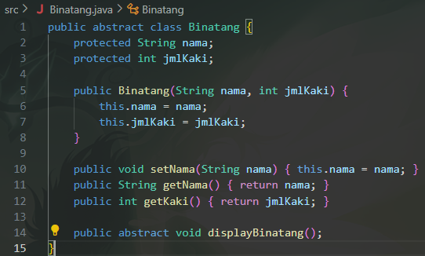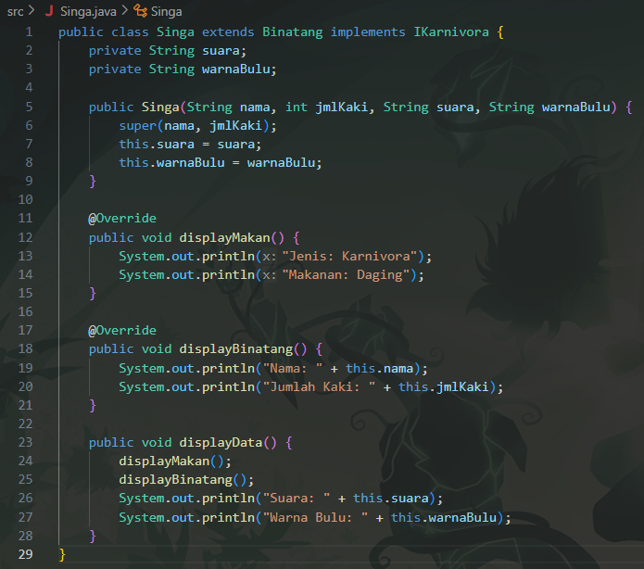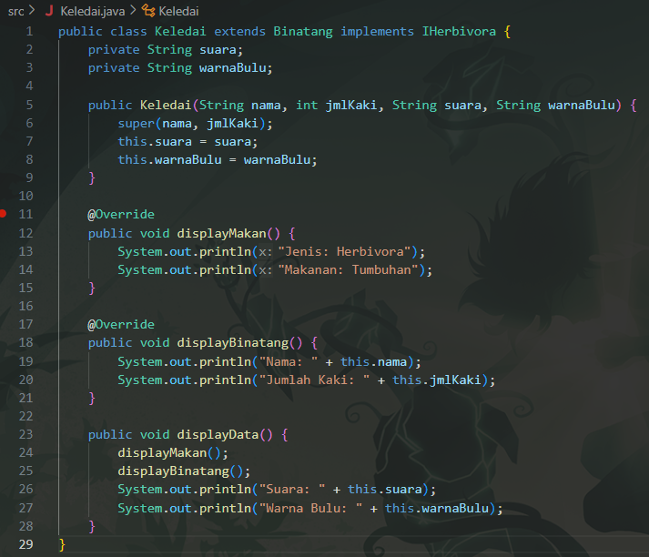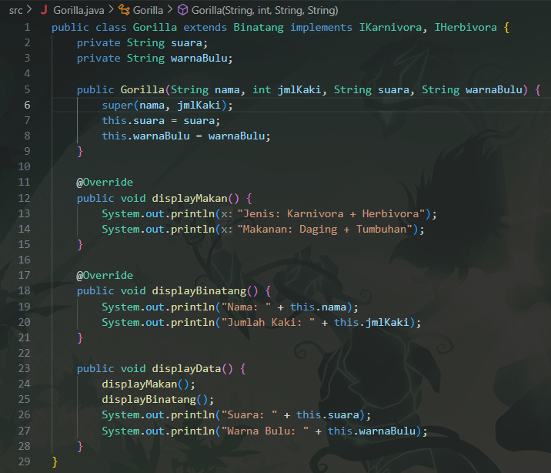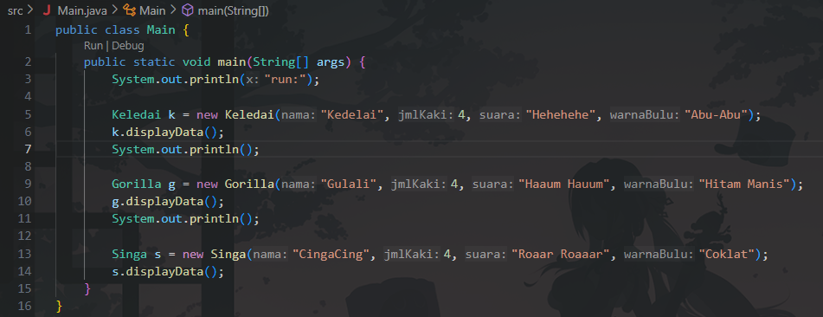

UML
